

**CMPE 202 - SW SEC-48 SYSTEMS ENGR**

**Submitted To** - Prof.Vinodh Gopinath

**Teacher Assistant** - Madhurima Dani

**Submitted By** - Rishikesh Andhare

UML Diagram:-(15 Points)

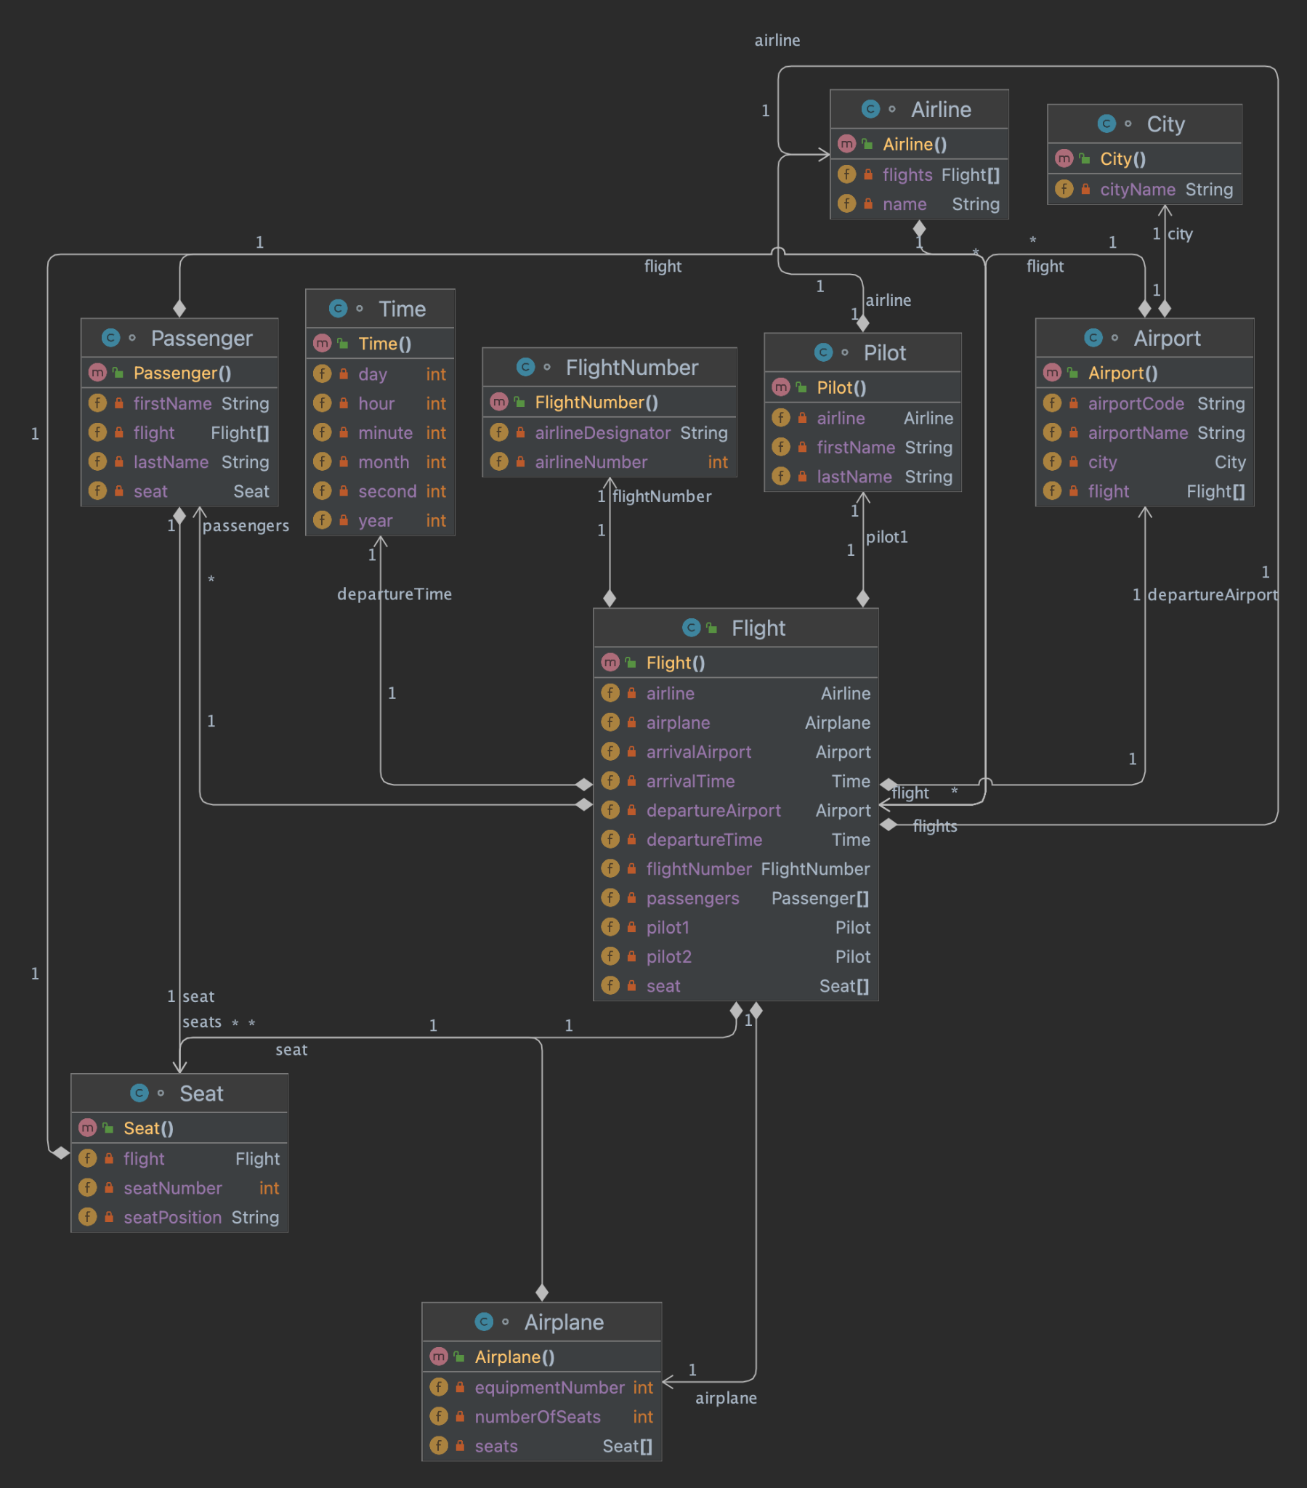

Ja

In the above diagram following classes have been created : -

* The Airline class represents an airline and includes its name and a list of flights that the airline operates.
* The Flight class represents a flight and includes details such as its flight number, departure and arrival airports (represented by the Airport class), departure and arrival times, the airplane used for the flight (represented by the Airplane class), a list of passengers, and the two pilots who operate the flight (represented by the Pilot class).
* The Airport class represents an airport and is characterized by its airport code.
* The Airplane class represents an airplane and includes details such as its airplane number, the number of seats it has (represented by the Seat class), and a list of flights that the airplane operates.
* The Seat class represents a seat and includes details such as its row number and position within the row.
* The Passenger class represents a passenger and includes details such as their name and the seat they occupy on a flight.
* The Pilot class represents a pilot and includes details such as their name and the airline they are employed by.
* The City class represents a city name.

The classes are associated with one another in several ways, including:

* A flight can have many passengers, but a passenger can only belong to one flight (one-to-many relationship).
* An airline can operate many flights, but a flight belongs to only one airline (one-to-many relationship).
* An airport can serve many flights, and a flight can depart from and arrive at many airports (many-to-many relationship).
* An airplane can operate many flights, and a flight can be operated by many airplanes (many-to-many relationship).

Java Declarations : - (5 Points)

| public class Airline {  private String name;  private Flight[] flights; }  public class Pilot {  private String firstName;  private String lastName;  private Airline airline; } public class FlightNumber {  private String airlineDesignator;  private int airlineNumber; }  public class Airport {  private City city;  private String airportCode;  private String airportName;  private Flight[] flight; }  public class Time {  private int hour;  private int minute;  private int second;  private int day;  private int month;  private int year; }  public class Flight {  private FlightNumber flightNumber;  private Airport departureAirport;  private Airport arrivalAirport;  private Time departureTime;  private Time arrivalTime;  private Pilot pilot1;  private Pilot pilot2;  private Seat[] seat;  private Airplane airplane;  private Passenger[] passengers;  private Airline airline; }  public class Passenger {  private String firstName;  private String lastName;  private Flight[] flight;  private Seat seat; }  public class Airplane {  private int numberOfSeats;  private int equipmentNumber;  private Seat[] seats; }  public class Seat {  private int seatNumber;  private String seatPosition;  private Flight flight; }  public class City {  private String cityName; } |
| --- |

Thank you